**I. Show instructor name only.**

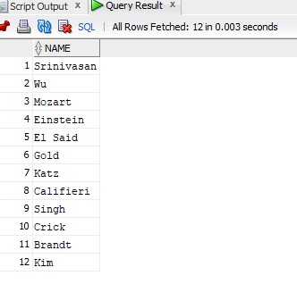

**II. Show course id and title only.**

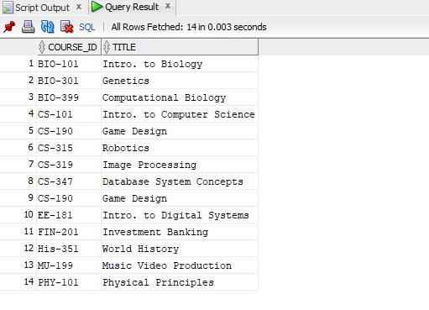

**III. Find instructor name and department of the instructor with id = 22222.**

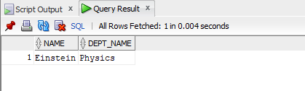

**IV. Find course title and credits of the courses offered by ‘Comp. Sci.’ department.**

**V. Find name and department of instructors who have a salary more than 70000.**

**VI. Find course title of the courses which are not less than 4 credits.**

**VII. Find name and department of instructors who have a salary in between 80000 and 100000 (bounds are inclusive).**

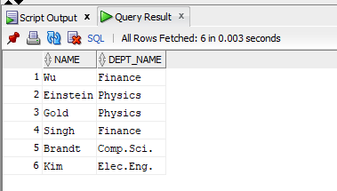

**VIII. Find course titles and credits of the courses not offered by ‘Comp. Sci.’ department.**

**IX. Display all records of instructor table.**

**X. Find all courses (display all columns) which are offered by ‘Biology’ department and credits is not 4.**

